Send Task Manager Tasks to Field Task Manager
@startuml
Participant “Task Manager” as TM
Participant “Field Task Manager” as FTM
TM -> FTM: Create(TM Tasks incl Task Id)
FTM -> FTM: Create FTM Tasks for contiguous region
FTM -> FTM: Map TM Tasks to FTM Subtasks>
loop for each non-contigious region
FTM -> FTM: Create FTM Tasks for contiguous region
FTM -> FTM: Map TM Tasks to FTM Subtasks
end

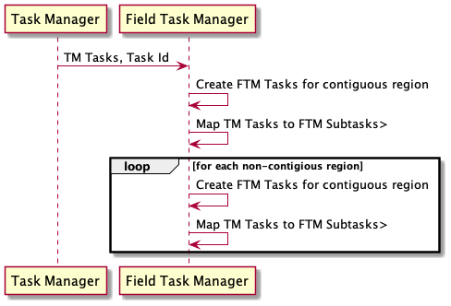
@enduml

Send Task Manager Field Task Manager Tasks Status Update to Task Manager
@startuml
Participant “Field Task Manager” as FTM
Participant “Task Manager” as TM
FTM -> TM: UpdateTask(Task Status, TM Task Id, FTM Task Id?)
TM -> TM: Update Task
TM -> TM: Do Something with Task Id?
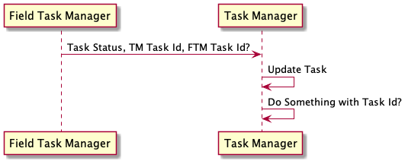
@enduml

Send Task Id to Task Manager to Invalidate
@startuml
Participant “Field Task Manager” as FTM
Participant “Task Manager” as TM
FTM -> TM: InvalidateTask(TM Task Id)
TM -> TM: Invalidate Task
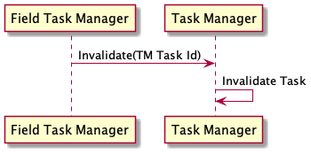
@enduml

Send Project to Field Task Manager
@startuml
Participant “Task Manager” as TM
Participant “Field Task Manager” as FTM
TM -> FTM: SomethingProject(TM Project incl Project Id)
FTM -> FTM: Now What?
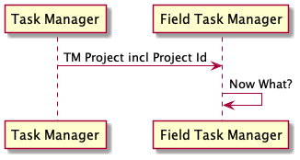
@enduml

Send Project Members to Field Task Manager
@startuml
Participant “Task Manager” as TM
Participant “Field Task Manager” as FTM
TM -> FTM: AddProjectMembers(TM Project Id, OSM Ids)
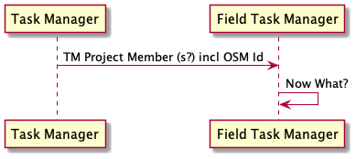
FTM -> FTM: Now What?
@enduml

Send Organization Profile to Field Task Manager
@startuml
Participant “Task Manager” as TM
Participant “Field Task Manager” as FTM
TM -> FTM: AddOrgProfile(TM Org Profile, Org Id)
FTM -> FTM: Now What?
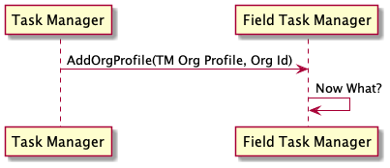
@enduml

Send User Profile to Field Task Manager
@startuml
Participant “Task Manager” as TM
Participant “Field Task Manager” as FTM
TM -> FTM: UpdateUserProfile(TM User Profile, OSM Id)
FTM -> FTM: Now What?
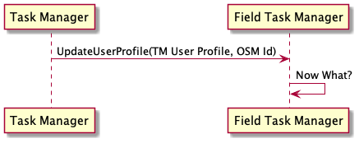
@enduml

